UNITED STATES
SECURITIES AND EXCHANGE COMMISSION
Washington, D.C. 20549

FORM 8-K

CURRENT REPORT

PURSUANT TO SECTION 13 OR 15(D) OF THE
SECURITIES EXCHANGE ACT OF 1934

Date of Report (Date of earliest event reported): September 14, 2026

SPECTRAL AI, INC.
(Exact name of registrant as specified in its charter)

Delaware |  | 001-40058 |  | 85-3987148
(State or other jurisdiction  of incorporation) |  | (Commission File Number) |  | (I.R.S. Employer  Identification No.)

2515 McKinney Avenue, Suite 1000  Dallas, Texas |  | 75201
(Address of principal executive offices) |  | (Zip Code)

(972) 499-4934
(Registrant’s telephone number, including area code)

Not Applicable
(Former name or former address, if changed since last report)

Check the appropriate box below if the Form 8-K is intended to simultaneously satisfy the filing obligation of the registrant under any of the following provisions:

☐ | Written communication pursuant to Rule 425 under the Securities Act (17 CFR 230.425)
☐ | Soliciting material pursuant to Rule 14a-12 under the Exchange Act (17 CFR 240.14a-12)
☐ | Pre-commencement communications pursuant to Rule 14d-2(b) under the Exchange Act (17 CFR 240.14d-2(b))
☐ | Pre-commencements communications pursuant to Rule 13e-4(c) under the Exchange Act (17 CFR 240.13e-4(c))

Securities registered pursuant to Section 12(b) of the Act:

Title of each class |  | Trading Symbols |  | Name of each exchange on which registered
Common Stock, par value $0.0001 per share |  | MDAI |  | The Nasdaq Stock Market LLC
Redeemable Warrants, each whole warrant exercisable for one share of Common Stock, at an exercise price of $2.75 per share |  | MDAIW |  | The Nasdaq Stock Market LLC

Indicate by check mark whether the registrant is an emerging growth company as defined in Rule 405 of the Securities Act of 1933 (§230.405 of this chapter) or Rule 12b-2 of the Securities Exchange Act of 1934 (§240.12b-2 of this chapter).

Emerging growth company ☒

If an emerging growth company, indicate by check mark if the registrant has elected not to use the extended transition period for complying with any new or revised financial accounting standards provided pursuant to Section 13(a) of the Exchange Act. ☐

Item 7.01. Regulation FD Disclosure.

On September 14, 2026, the Company posted an investor presentation to its website at www.spectral-ai.com (the “Investor Presentation”). A copy of the Investor Presentation is furnished as Exhibit 99.1 to this Current Report on Form 8-K and is incorporated herein by reference. The Company will use the Investor Presentation, in whole or in part, and possibly with modifications, in connection with presentations to investors, analysts and others.

The information in this Item 7.01 to this Current Report on Form 8-K, and in Exhibit 99.1 furnished herewith, shall not be deemed to be “filed” for purposes of Section 18 of the Securities Exchange Act of 1934, as amended (the “Exchange Act”), or otherwise subject to the liabilities of that section, nor shall such information be deemed incorporated by reference in any filing under the Securities Act of 1933, as amended, or the Exchange Act, except as expressly set forth by specific reference in such a filing.

Item 9.01. Financial Statements and Exhibits.

(d) Exhibits

Exhibit No. |  | Description
99.1 |  | Spectral AI Investor Presentation, dated September 14, 2026.
104 |  | Cover Page Interactive Data File (embedded within the Inline XBRL document)

1

SIGNATURES

Pursuant to the requirements of the Securities Exchange Act of 1934, the registrant has duly caused this Current Report to be signed on its behalf by the undersigned hereunto duly authorized.

Dated: September 15, 2026

 | SPECTRAL AI, INC.
 | By: | /s/ Vincent S. Capone
 | Name: | Vincent S. Capone
 | Title: | Chief Executive Officer

2

Exhibit 99.1

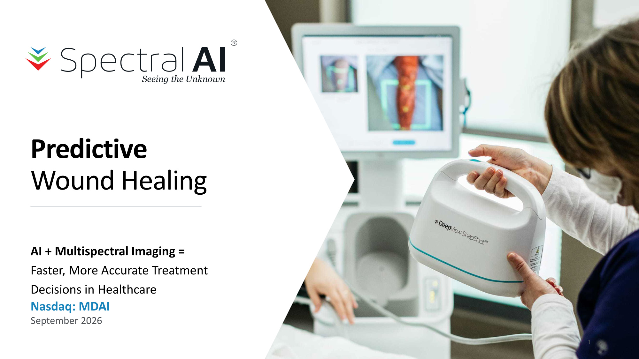
Predictive Wound Healing AI + Multispectral Imaging = Faster, More Accurate Treatment Decisions in Healthcare Nasdaq: MDAI September 2026 1

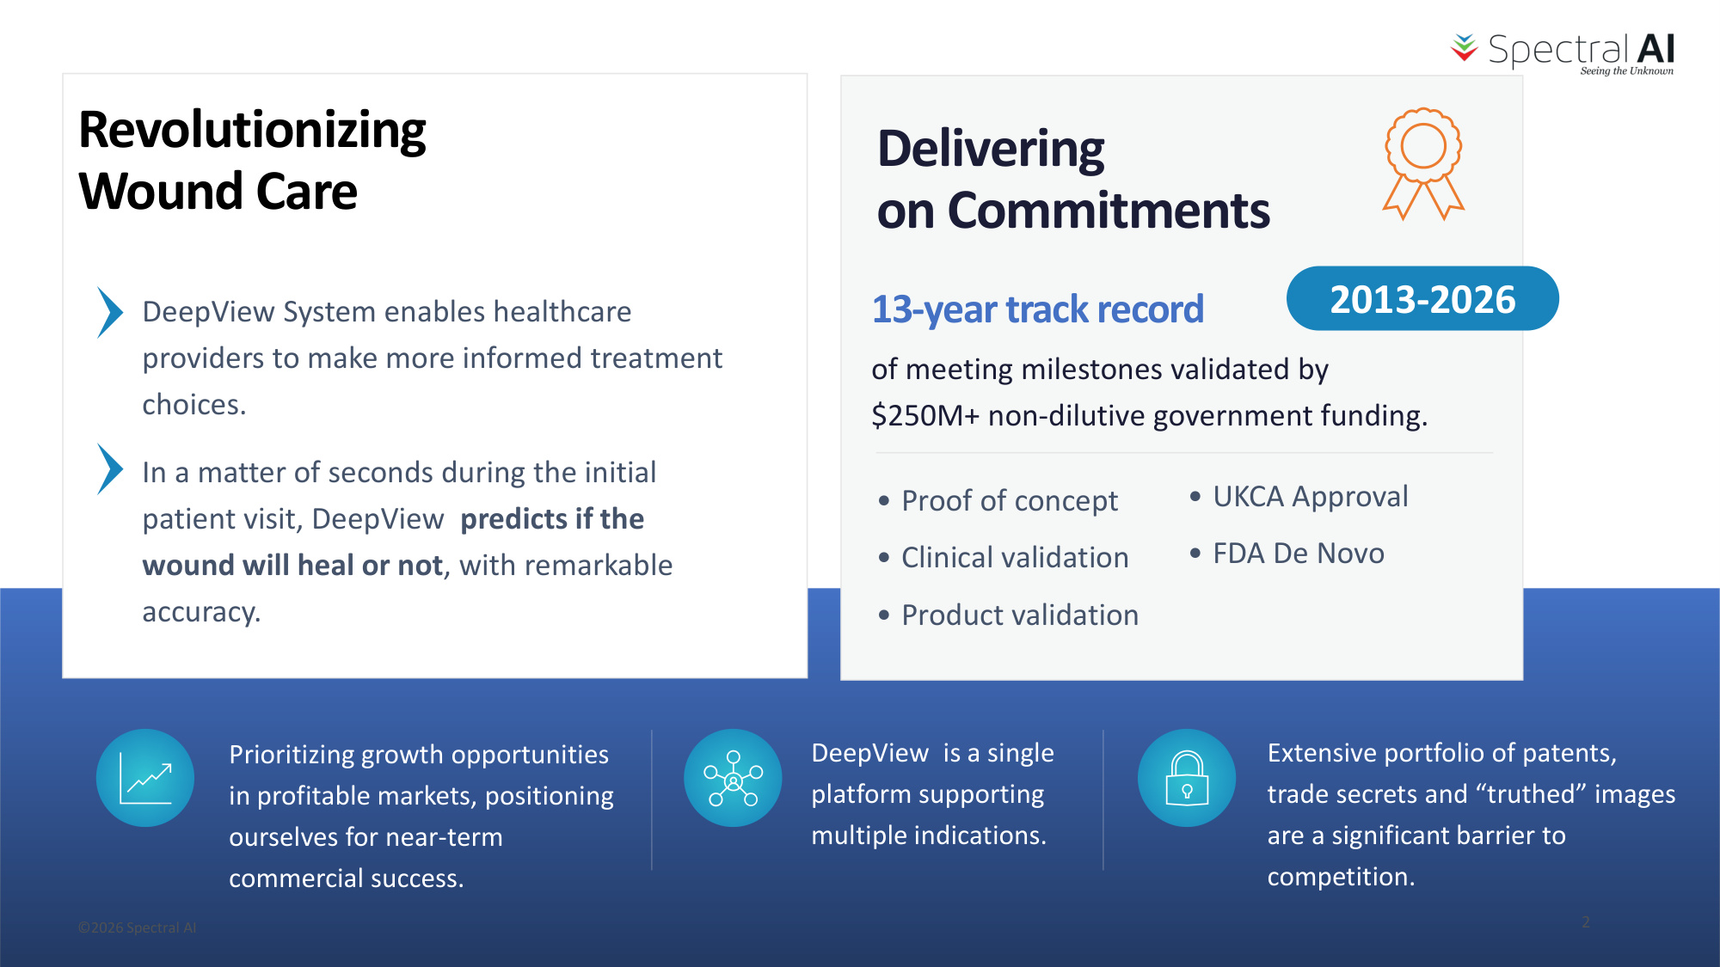
Revolutionizing Wound Care Delivering on Commitments 13-year track record of meeting milestones validated by $250M+ non-dilutive government funding. • Proof of concept • Clinical validation • Product validation Prioritizing growth opportunities in profitable markets, positioning ourselves for near-term commercial success. • UKCA Approval • FDA De Novo 2013-2026 DeepView is a single platform supporting multiple indications. Extensive portfolio of patents, trade secrets and "truthed" images are a significant barrier to competition. DeepView System enables healthcare providers to make more informed treatment choices. In a matter of seconds during the initial patient visit, DeepView predicts if the wound will heal or not, with remarkable accuracy. ©2026 Spectral AI 2

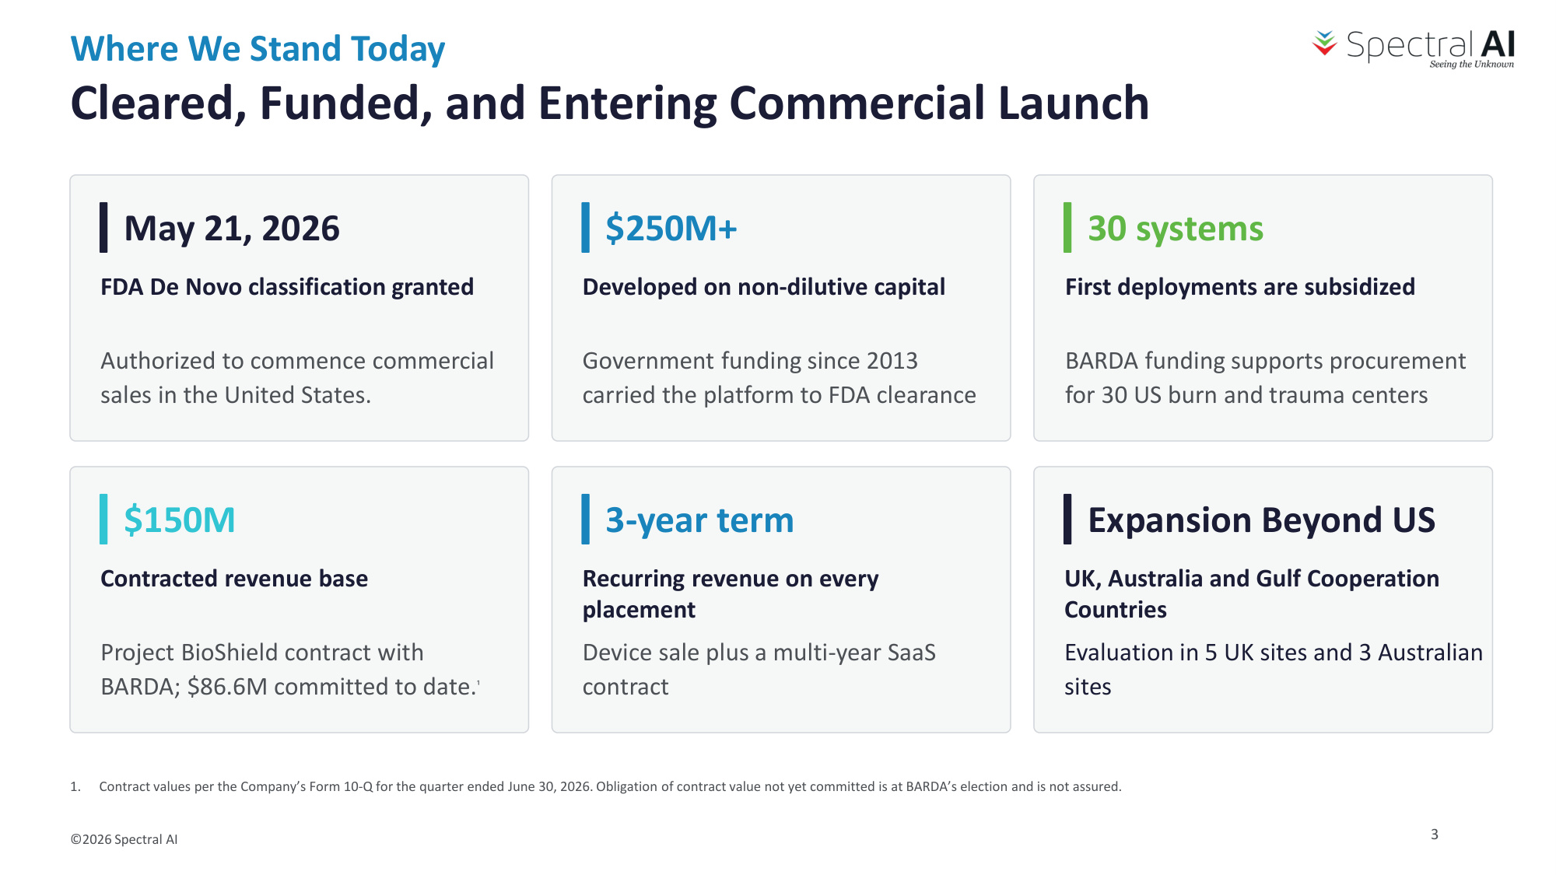
Where We Stand Today Cleared, Funded, and Entering Commercial Launch May 21, 2026 FDA De Novo classification granted Authorized to commence commercial sales in the United States. $250M+ Developed on non-dilutive capital Government funding since 2013 carried the platform to FDA clearance 30 systems First deployments are subsidized BARDA funding supports procurement for 30 US burn and trauma centers $150M Contracted revenue base Project BioShield contract with BARDA; $86.6M committed to date.¹ 3-year term Recurring revenue on every placement Device sale plus a multi-year SaaS contract Expansion Beyond US UK, Australia and Gulf Cooperation Countries Evaluation in 5 UK sites and 3 Australian sites 1. Contract values per the Company's Form 10-Q for the quarter ended June 30, 2026. Obligation of contract value not yet committed is at BARDA's election and is not assured. ©2026 Spectral AI 3

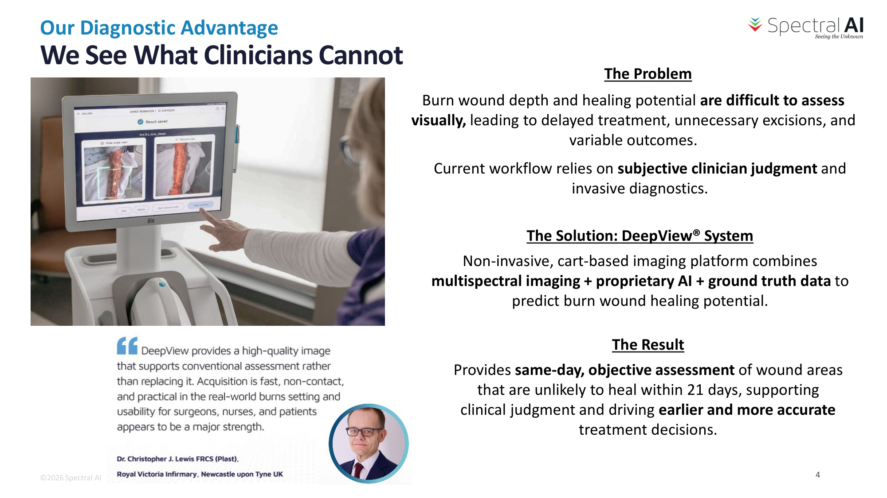
We See What Clinicians Cannot Burn wound depth and healing potential are difficult to assess visually, leading to delayed treatment, unnecessary excisions, and variable outcomes. The Result Provides same-day, objective assessment of wound areas that are unlikely to heal within 21 days, supporting clinical judgment and driving earlier and more accurate treatment decisions. The Problem Current workflow relies on subjective clinician judgment and invasive diagnostics. The Solution: DeepView® System Non-invasive, cart-based imaging platform combines multispectral imaging + proprietary AI + ground truth data to predict burn wound healing potential. ©2026 Spectral AI Our Diagnostic Advantage 4

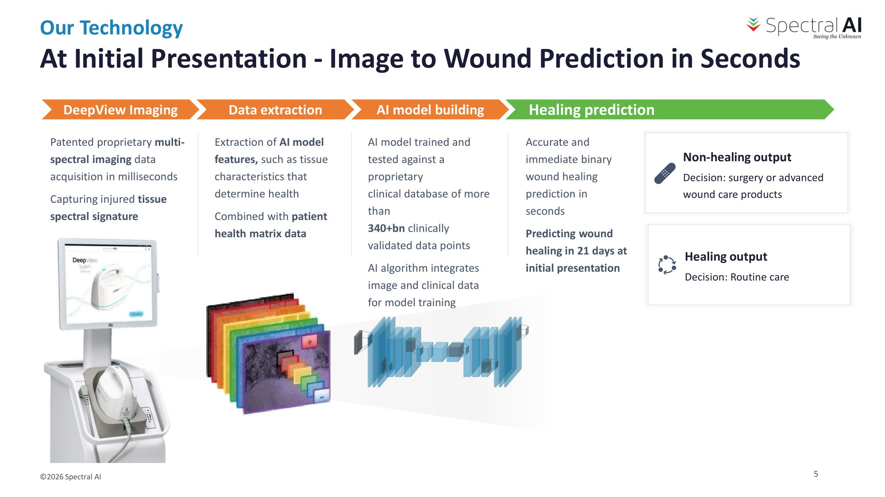
DeepView Imaging Patented proprietary multi- spectral imaging data acquisition in milliseconds Capturing injured tissue spectral signature Data extraction Extraction of AI model features, such as tissue characteristics that determine health Combined with patient health matrix data AI model trained and tested against a proprietary clinical database of more than 340+bn clinically validated data points AI algorithm integrates image and clinical data for model training AI model building Accurate and immediate binary wound healing prediction in seconds Predicting wound healing in 21 days at initial presentation Healing prediction Non-healing output Decision: surgery or advanced wound care products Healing output Decision: Routine care At Initial Presentation - Image to Wound Prediction in Seconds ©2026 Spectral AI Our Technology 5

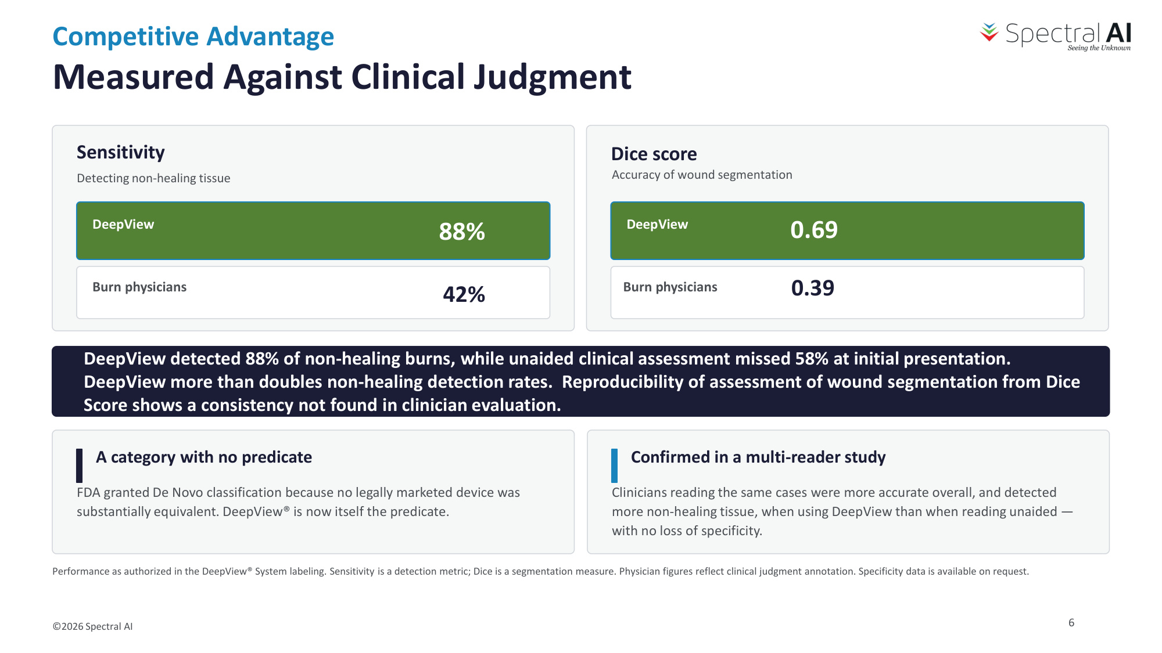
Competitive Advantage Measured Against Clinical Judgment ©2026 Spectral AI Sensitivity Detecting non-healing tissue DeepView 88% Burn physicians 42% DeepView Dice score Accuracy of wound segmentation 0.39 DeepView detected 88% of non-healing burns, while unaided clinical assessment missed 58% at initial presentation. DeepView more than doubles non-healing detection rates. Reproducibility of assessment of wound segmentation from Dice Score shows a consistency not found in clinician evaluation. A category with no predicate FDA granted De Novo classification because no legally marketed device was substantially equivalent. DeepView® is now itself the predicate. Confirmed in a multi-reader study Clinicians reading the same cases were more accurate overall, and detected more non-healing tissue, when using DeepView than when reading unaided — with no loss of specificity. Performance as authorized in the DeepView® System labeling. Sensitivity is a detection metric; Dice is a segmentation measure. Physician figures reflect clinical judgment annotation. Specificity data is available on request. 0.69 Burn physicians 6

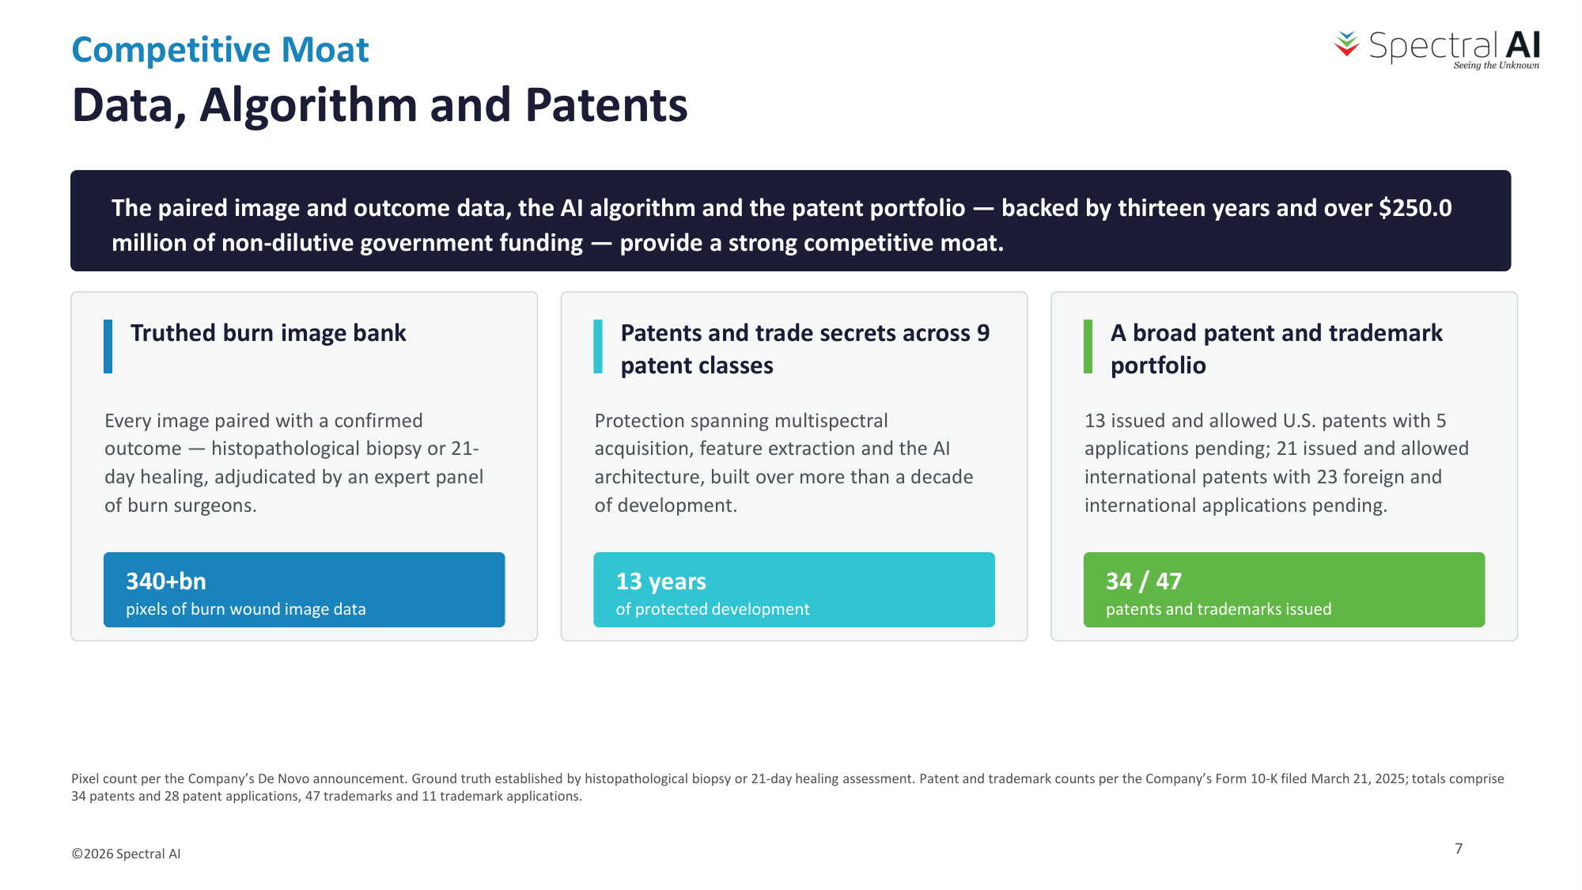
Competitive Moat Data, Algorithm and Patents ©2026 Spectral AI The paired image and outcome data, the AI algorithm and the patent portfolio — backed by thirteen years and over $250.0 million of non-dilutive government funding — provide a strong competitive moat. Truthed burn image bank Every image paired with a confirmed outcome — histopathological biopsy or 21- day healing, adjudicated by an expert panel of burn surgeons. 340+bn pixels of burn wound image data Patents and trade secrets across 9 patent classes Protection spanning multispectral acquisition, feature extraction and the AI architecture, built over more than a decade of development. 13 years of protected development A broad patent and trademark portfolio 13 issued and allowed U.S. patents with 5 applications pending; 21 issued and allowed international patents with 23 foreign and international applications pending. 34 / 47 patents and trademarks issued Pixel count per the Company's De Novo announcement. Ground truth established by histopathological biopsy or 21-day healing assessment. Patent and trademark counts per the Company's Form 10-K filed March 21, 2025; totals comprise 34 patents and 28 patent applications, 47 trademarks and 11 trademark applications. 7

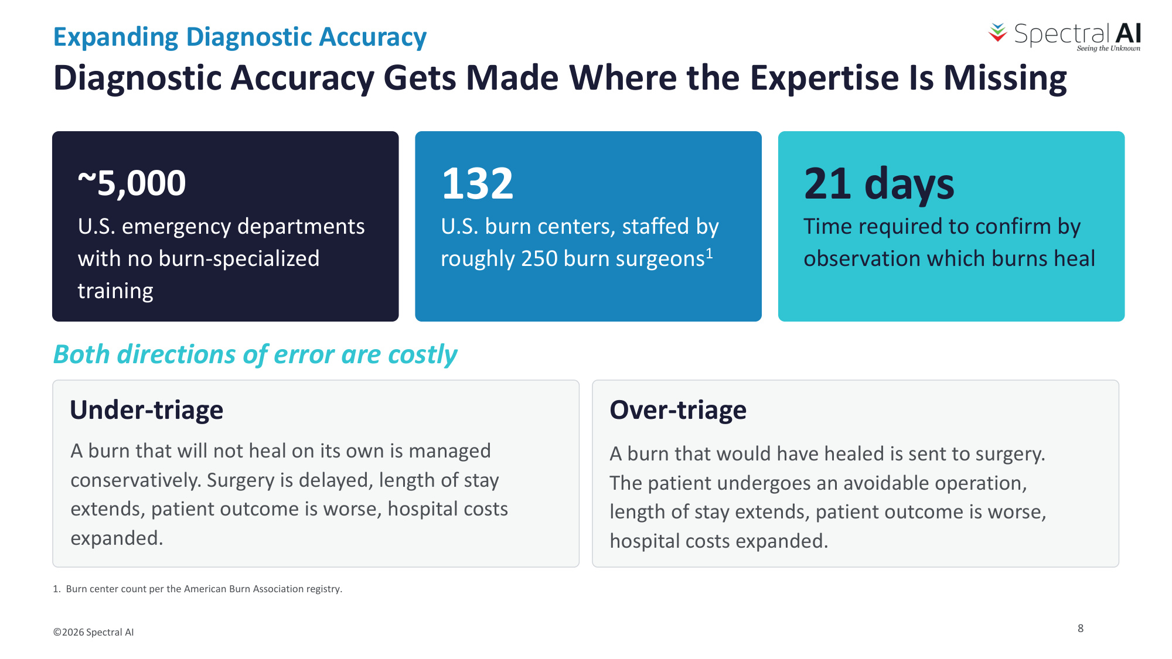
Expanding Diagnostic Accuracy Diagnostic Accuracy Gets Made Where the Expertise Is Missing ©2026 Spectral AI ~5,000 U.S. emergency departments with no burn-specialized training 132 U.S. burn centers, staffed by roughly 250 burn surgeons1 21 days Time required to confirm by observation which burns heal Both directions of error are costly Under-triage A burn that will not heal on its own is managed conservatively. Surgery is delayed, length of stay extends, patient outcome is worse, hospital costs expanded. Over-triage A burn that would have healed is sent to surgery. The patient undergoes an avoidable operation, length of stay extends, patient outcome is worse, hospital costs expanded. 1. Burn center count per the American Burn Association registry. 8

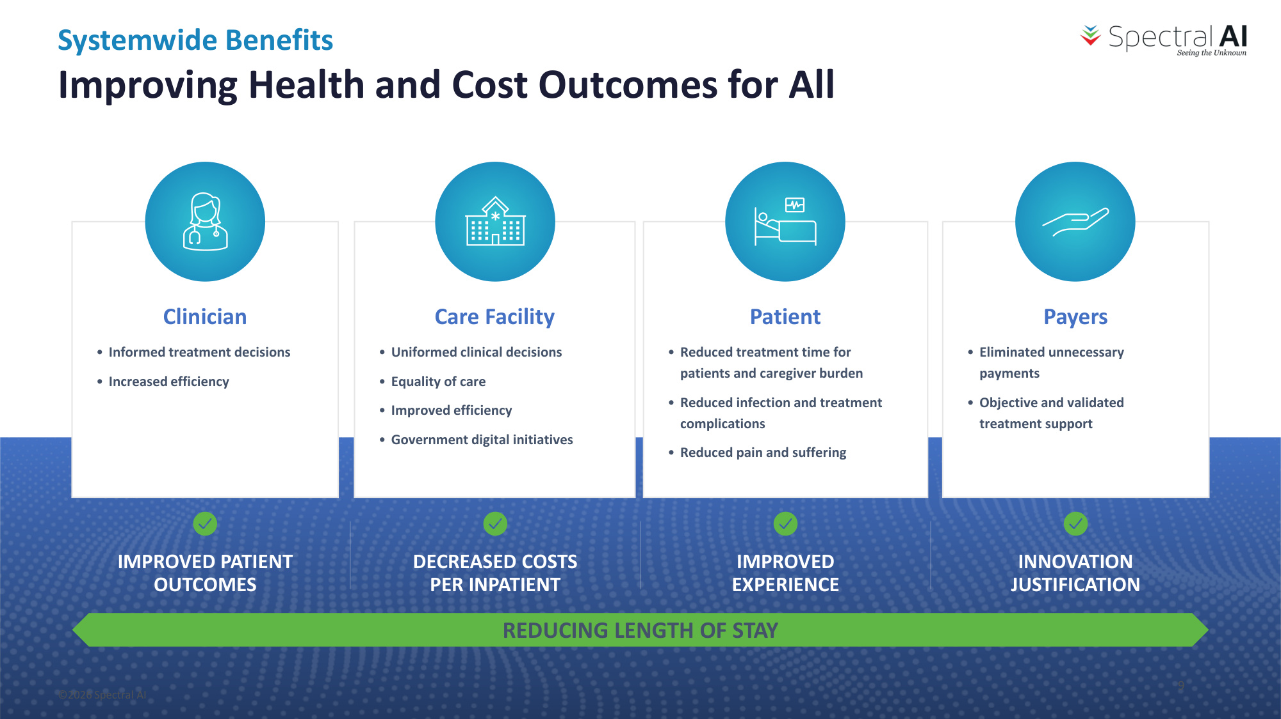
Clinician • Informed treatment decisions • Increased efficiency Care Facility • Uniformed clinical decisions • Equality of care • Improved efficiency • Government digital initiatives Patient • Reduced treatment time for patients and caregiver burden • Reduced infection and treatment complications • Reduced pain and suffering Payers • Eliminated unnecessary payments • Objective and validated treatment support REDUCING LENGTH OF STAY IMPROVED PATIENT OUTCOMES DECREASED COSTS PER INPATIENT IMPROVED EXPERIENCE INNOVATION JUSTIFICATION ©2026 Spectral AI Systemwide Benefits Improving Health and Cost Outcomes for All 9

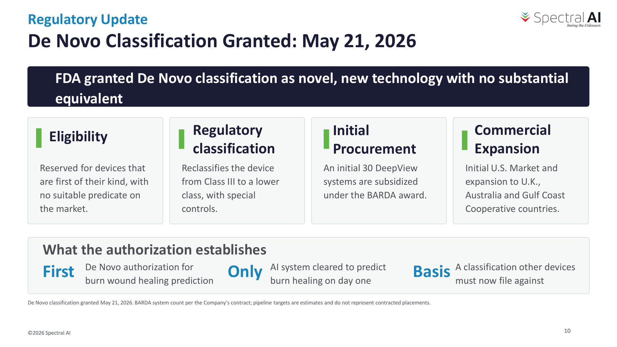
Regulatory Update De Novo Classification Granted: May 21, 2026 ©2026 Spectral AI FDA granted De Novo classification as novel, new technology with no substantial equivalent Eligibility Reserved for devices that are first of their kind, with no suitable predicate on the market. Regulatory classification Reclassifies the device from Class III to a lower class, with special controls. Initial Procurement An initial 30 DeepView systems are subsidized under the BARDA award. Commercial Expansion Initial U.S. Market and expansion to U.K., Australia and Gulf Coast Cooperative countries. What the authorization establishes First De Novo authorization for burn wound healing prediction Only AI system cleared to predict burn healing on day one Basis A classification other devices must now file against De Novo classification granted May 21, 2026. BARDA system count per the Company's contract; pipeline targets are estimates and do not represent contracted placements. 10

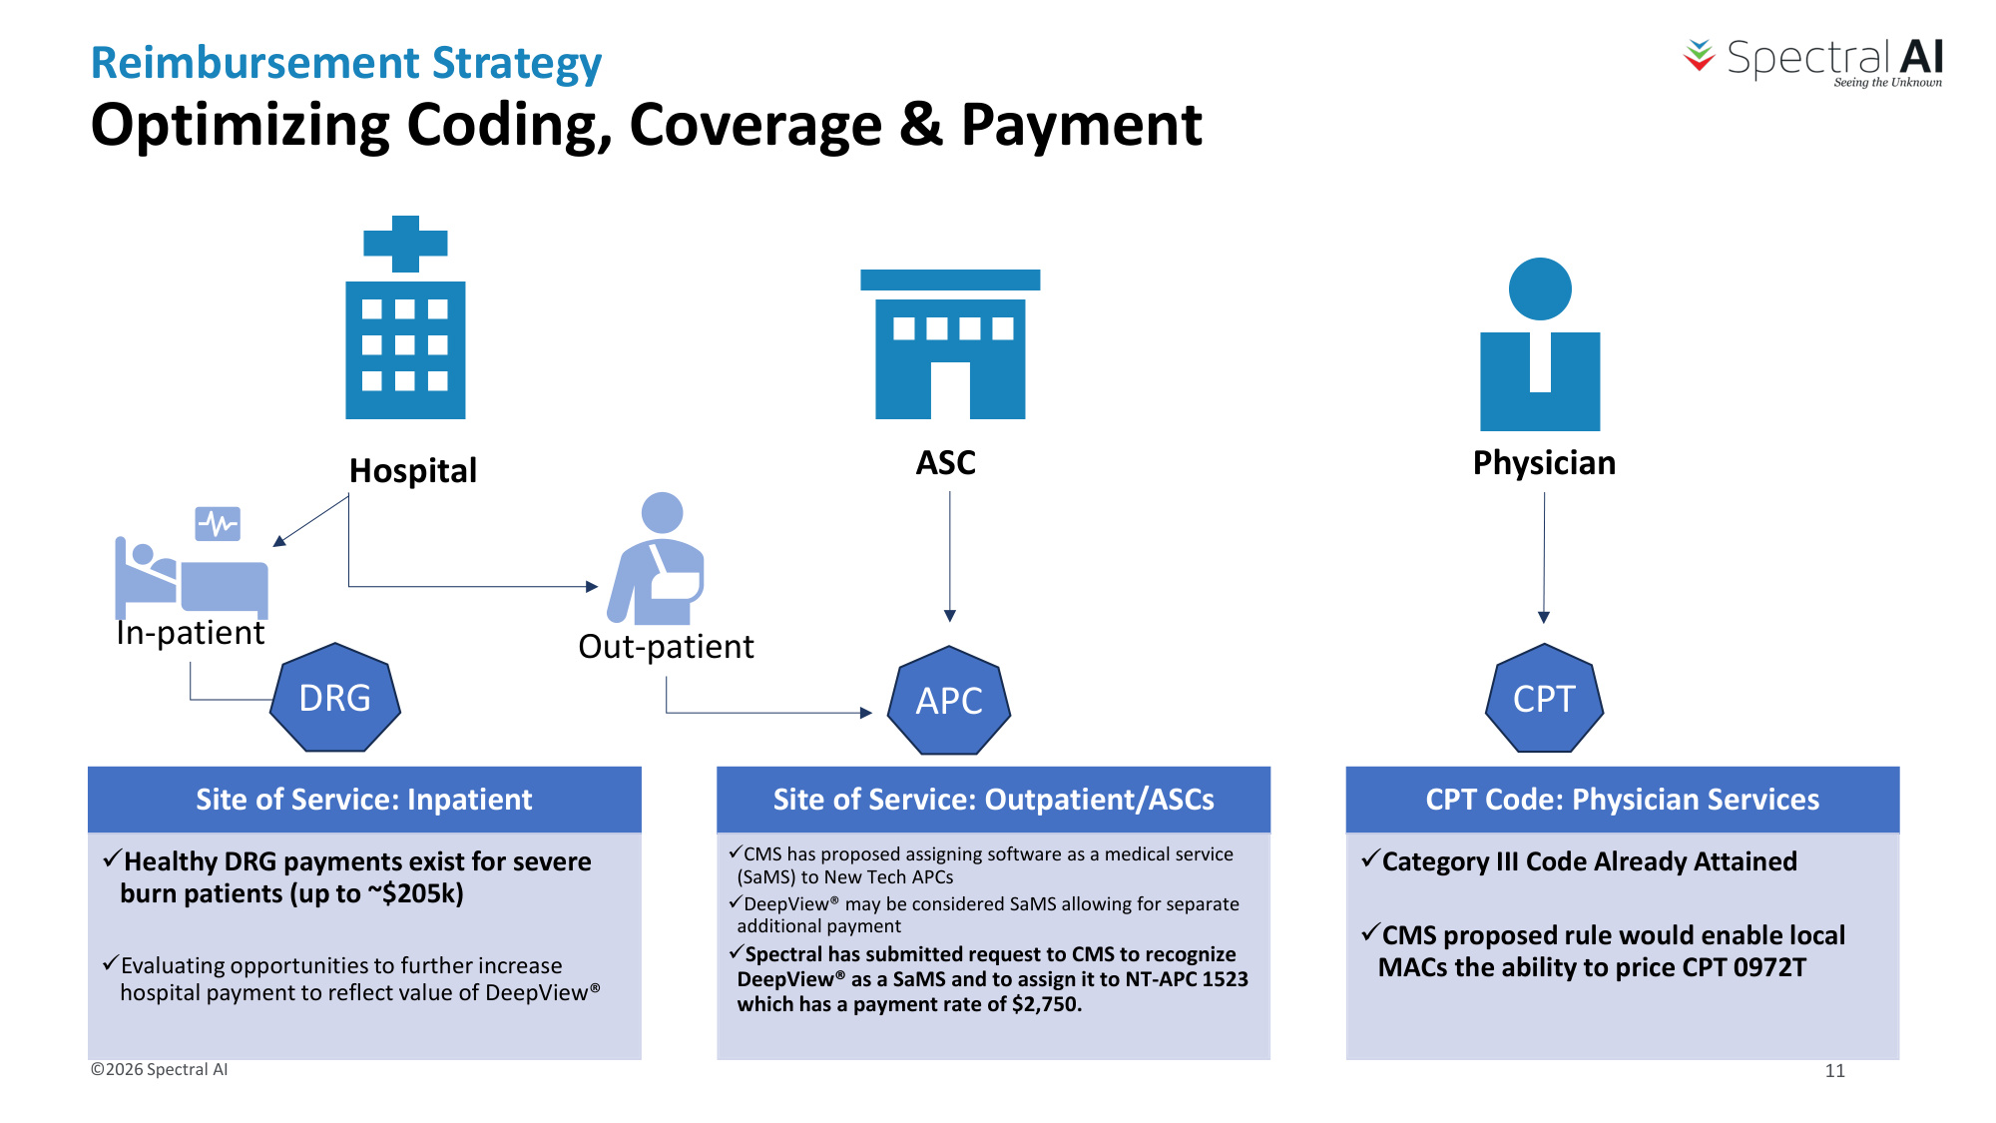
Optimizing Coding, Coverage & Payment Site of Service: Inpatient üHealthy DRG payments exist for severe burn patients (up to ~$205k) üEvaluating opportunities to further increase hospital payment to reflect value of DeepView® Site of Service: Outpatient/ASCs üCMS has proposed assigning software as a medical service (SaMS) to New Tech APCs üDeepView® may be considered SaMS allowing for separate additional payment üSpectral has submitted request to CMS to recognize DeepView® as a SaMS and to assign it to NT-APC 1523 which has a payment rate of $2,750. CPT Code: Physician Services üCategory III Code Already Attained üCMS proposed rule would enable local MACs the ability to price CPT 0972T ASC In-patient Out-patient Physician Hospital DRG APC CPT Reimbursement Strategy ©2026 Spectral AI 11

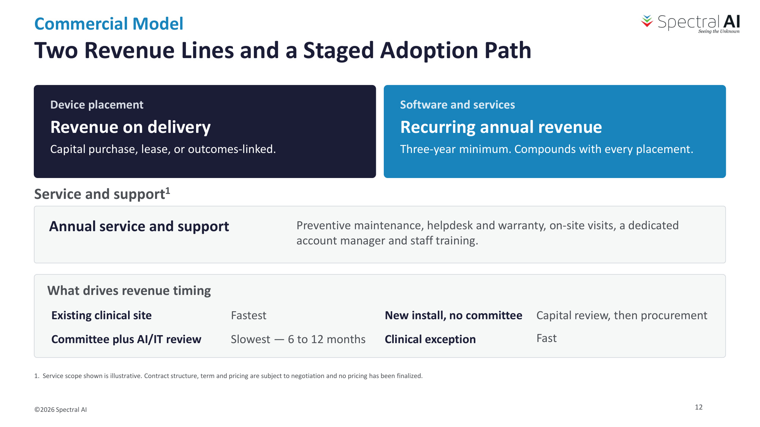
Commercial Model Two Revenue Lines and a Staged Adoption Path ©2026 Spectral AI Device placement Revenue on delivery Capital purchase, lease, or outcomes-linked. Software and services Recurring annual revenue Three-year minimum. Compounds with every placement. Service and support1 What drives revenue timing Existing clinical site Fastest New install, no committee Capital review, then procurement Committee plus AI/IT review Slowest — 6 to 12 months Clinical exception Fast Annual service and support Preventive maintenance, helpdesk and warranty, on-site visits, a dedicated account manager and staff training. 1. Service scope shown is illustrative. Contract structure, term and pricing are subject to negotiation and no pricing has been finalized. 12

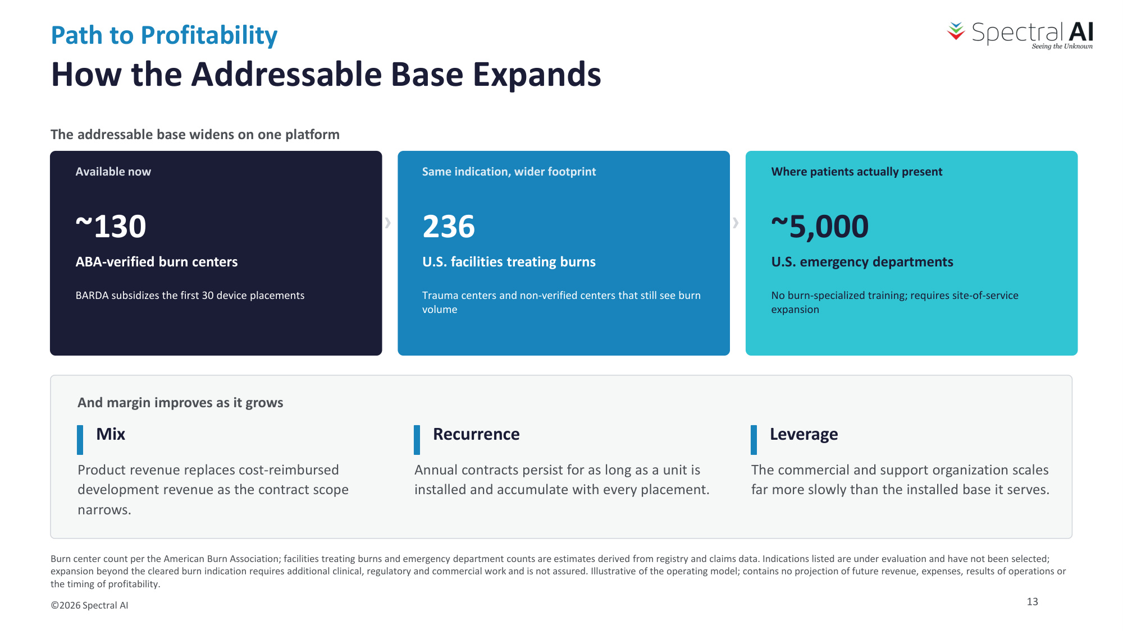
Path to Profitability How the Addressable Base Expands ©2026 Spectral AI The addressable base widens on one platform Available now ~130 ABA-verified burn centers BARDA subsidizes the first 30 device placements › Same indication, wider footprint 236 U.S. facilities treating burns Trauma centers and non-verified centers that still see burn volume › Where patients actually present ~5,000 U.S. emergency departments No burn-specialized training; requires site-of-service expansion And margin improves as it grows Mix Product revenue replaces cost-reimbursed development revenue as the contract scope narrows. Recurrence Annual contracts persist for as long as a unit is installed and accumulate with every placement. Leverage The commercial and support organization scales far more slowly than the installed base it serves. Burn center count per the American Burn Association; facilities treating burns and emergency department counts are estimates derived from registry and claims data. Indications listed are under evaluation and have not been selected; expansion beyond the cleared burn indication requires additional clinical, regulatory and commercial work and is not assured. Illustrative of the operating model; contains no projection of future revenue, expenses, results of operations or the timing of profitability. 13

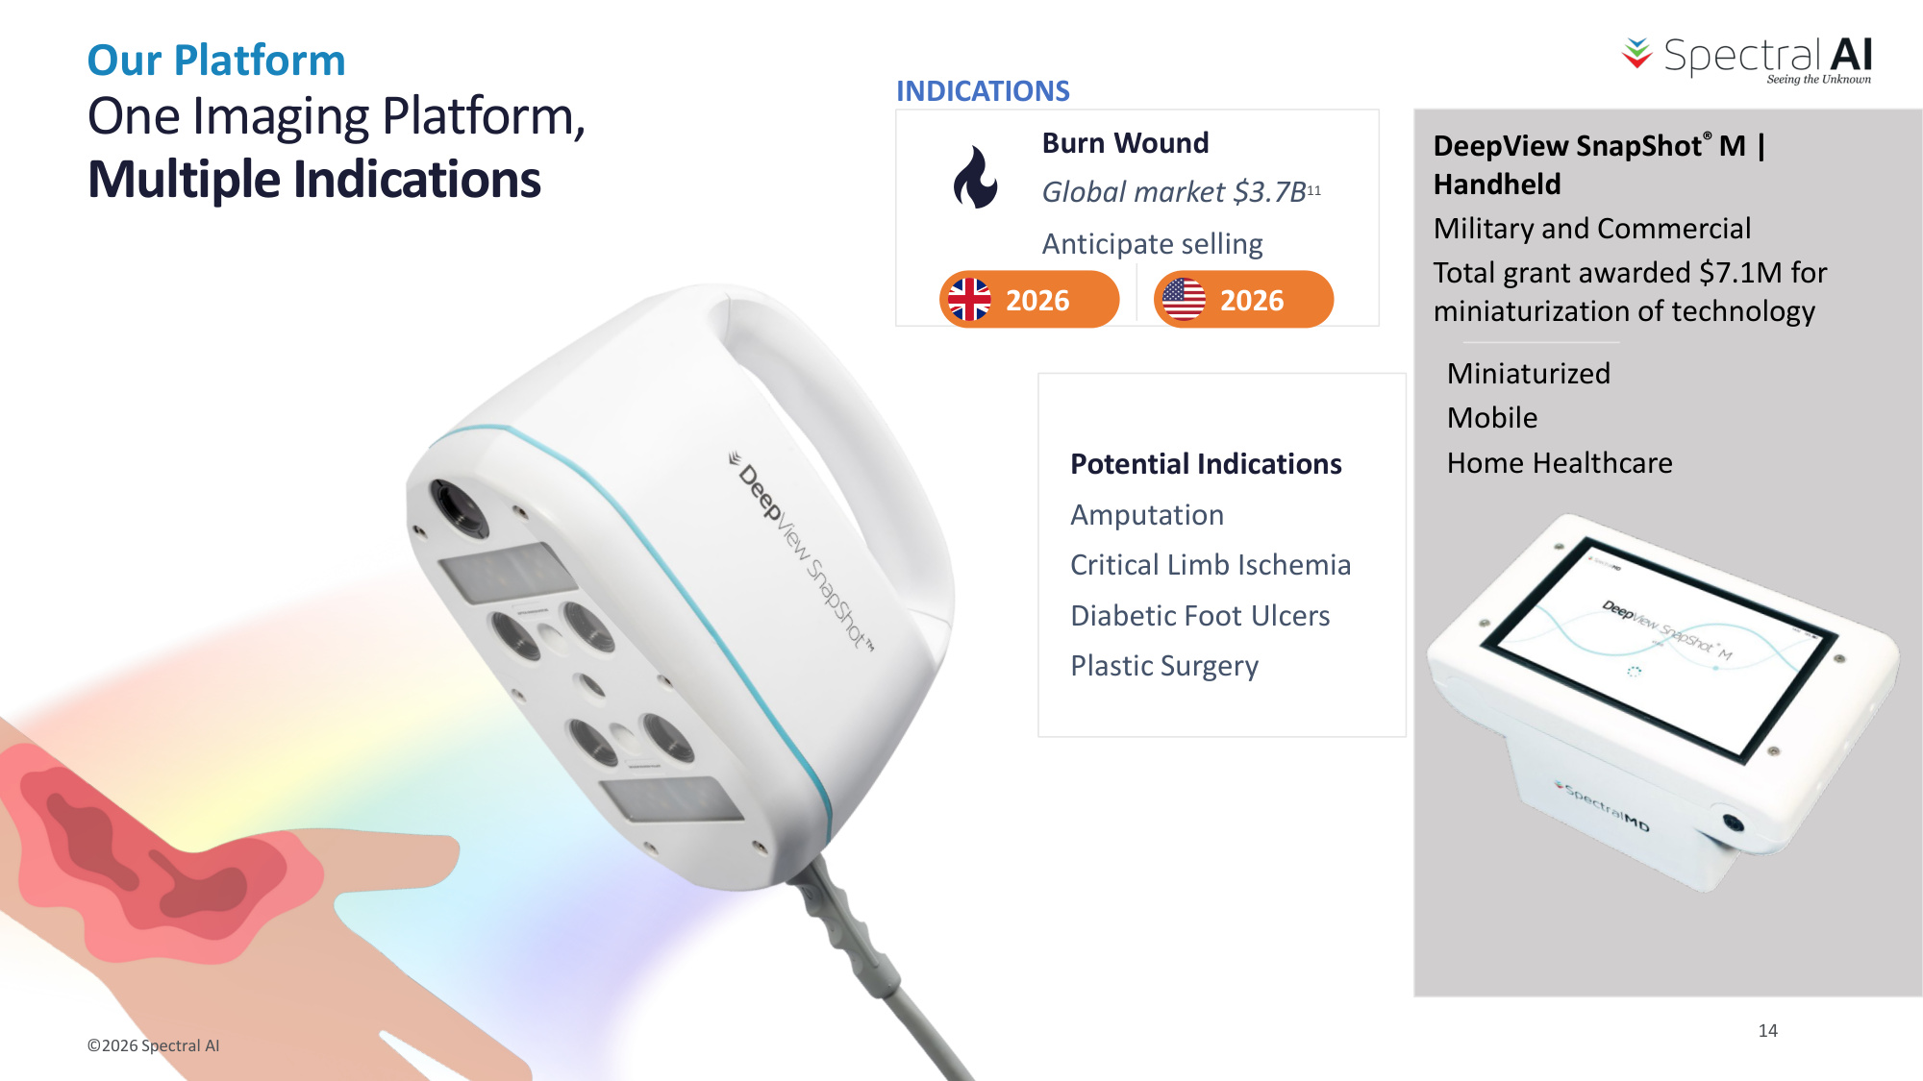
©2026 Spectral AI One Imaging Platform, Multiple Indications Potential Indications Amputation Critical Limb Ischemia Diabetic Foot Ulcers Plastic Surgery Miniaturized Mobile Home Healthcare Burn Wound Global market $3.7B11 Anticipate selling 2026 2026 DeepView SnapShot® M | Handheld Military and Commercial INDICATIONS Total grant awarded $7.1M for miniaturization of technology Our Platform 14

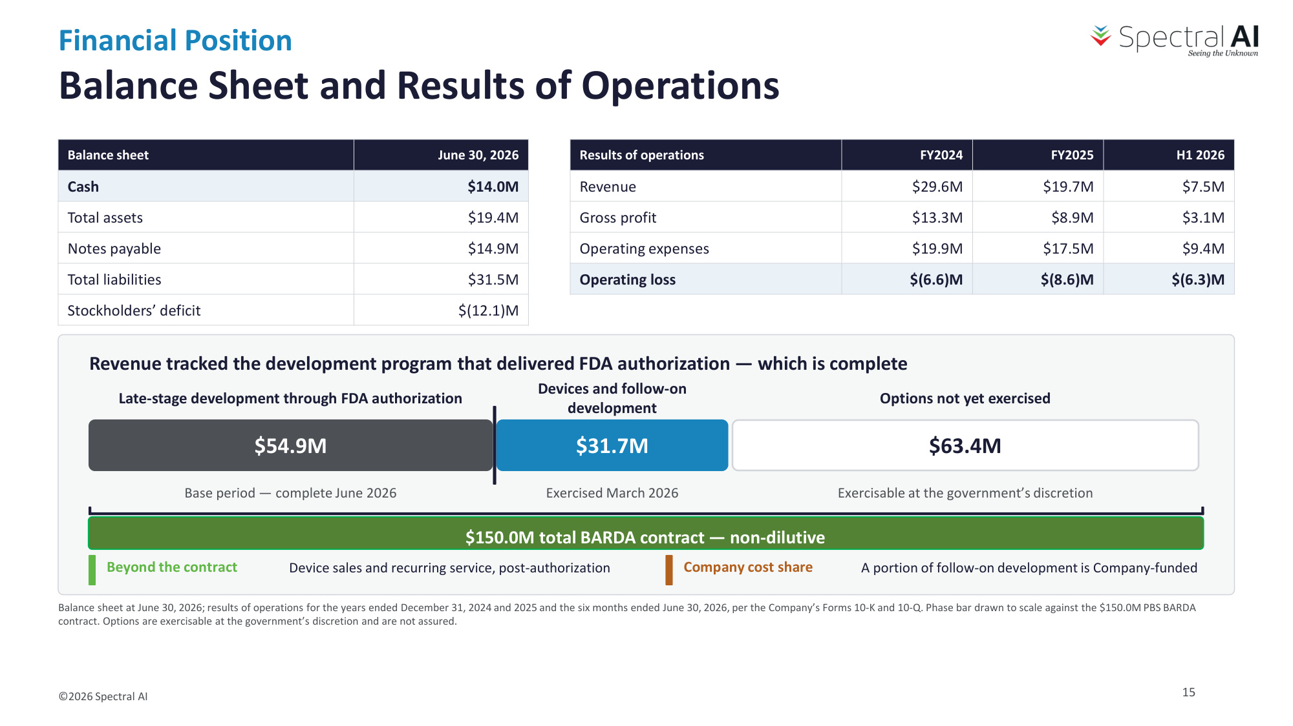
Financial Position Balance Sheet and Results of Operations ©2026 Spectral AI Balance sheet June 30, 2026 Cash $14.0M Total assets $19.4M Notes payable $14.9M Total liabilities $31.5M Stockholders' deficit $(12.1)M Results of operations FY2024 FY2025 H1 2026 Revenue $29.6M $19.7M $7.5M Gross profit $13.3M $8.9M $3.1M Operating expenses $19.9M $17.5M $9.4M Operating loss $(6.6)M $(8.6)M $(6.3)M Revenue tracked the development program that delivered FDA authorization — which is complete $54.9M Late-stage development through FDA authorization Base period — complete June 2026 $31.7M Devices and follow-on development Exercised March 2026 $63.4M Options not yet exercised Exercisable at the government's discretion Beyond the contract Device sales and recurring service, post-authorization Company cost share A portion of follow-on development is Company-funded Balance sheet at June 30, 2026; results of operations for the years ended December 31, 2024 and 2025 and the six months ended June 30, 2026, per the Company's Forms 10-K and 10-Q. Phase bar drawn to scale against the $150.0M PBS BARDA contract. Options are exercisable at the government's discretion and are not assured. 15 $150.0M total BARDA contract — non-dilutive

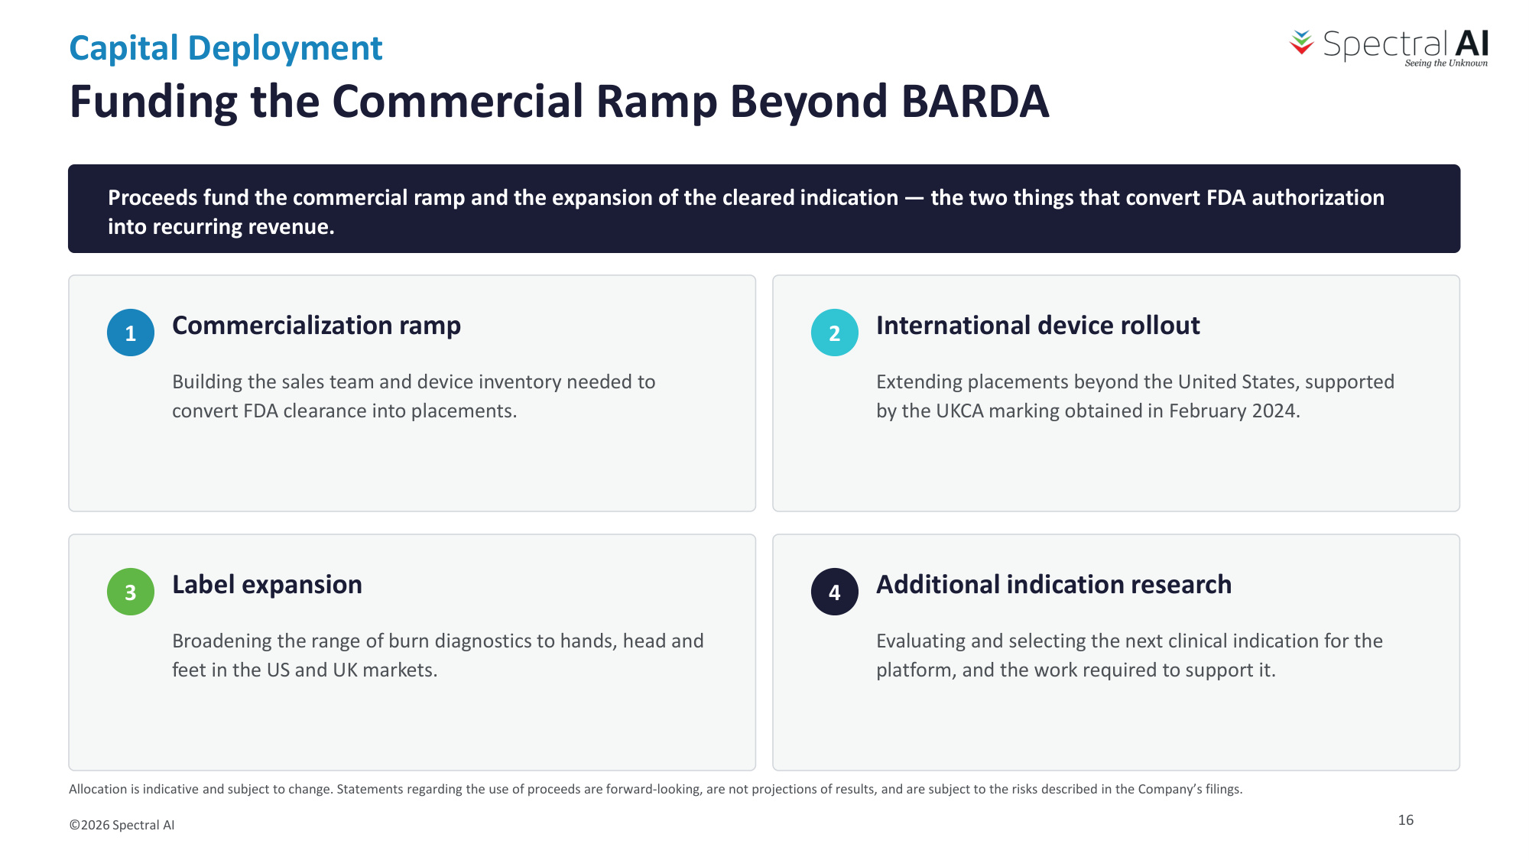
Capital Deployment Funding the Commercial Ramp Beyond BARDA ©2026 Spectral AI Proceeds fund the commercial ramp and the expansion of the cleared indication — the two things that convert FDA authorization into recurring revenue. 1 Commercialization ramp Building the sales team and device inventory needed to convert FDA clearance into placements. 2 International device rollout Extending placements beyond the United States, supported by the UKCA marking obtained in February 2024. 3 Label expansion Broadening the range of burn diagnostics to hands, head and feet in the US and UK markets. 4 Additional indication research Evaluating and selecting the next clinical indication for the platform, and the work required to support it. Allocation is indicative and subject to change. Statements regarding the use of proceeds are forward-looking, are not projections of results, and are subject to the risks described in the Company's filings. 16

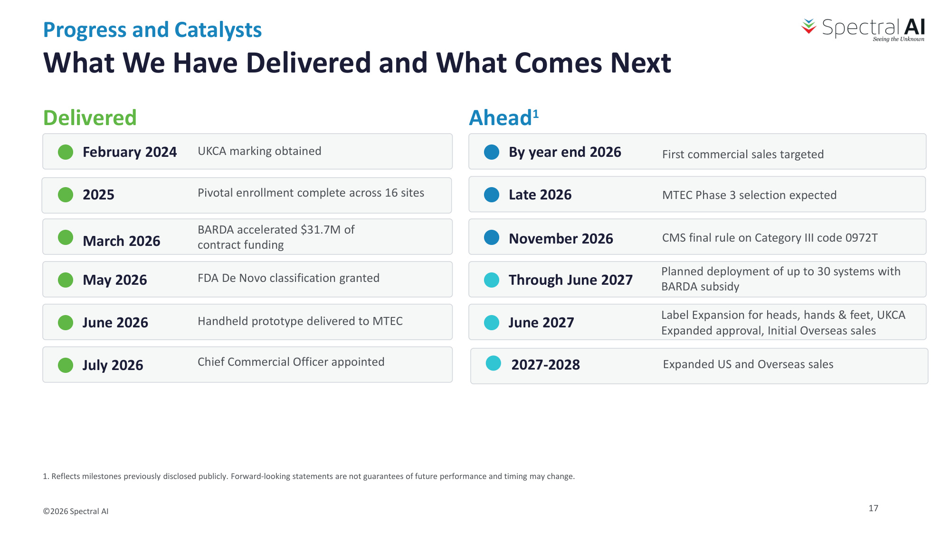
Progress and Catalysts What We Have Delivered and What Comes Next ©2026 Spectral AI Delivered February 2024 UKCA marking obtained 2025 Pivotal enrollment complete across 16 sites March 2026 BARDA accelerated $31.7M of contract funding May 2026 FDA De Novo classification granted June 2026 Handheld prototype delivered to MTEC July 2026 Chief Commercial Officer appointed Ahead1 By year end 2026 First commercial sales targeted Late 2026 MTEC Phase 3 selection expected November 2026 CMS final rule on Category III code 0972T Through June 2027 Planned deployment of up to 30 systems with BARDA subsidy June 2027 Label Expansion for heads, hands & feet, UKCA Expanded approval, Initial Overseas sales 1. Reflects milestones previously disclosed publicly. Forward-looking statements are not guarantees of future performance and timing may change. 2027-2028 Expanded US and Overseas sales 17

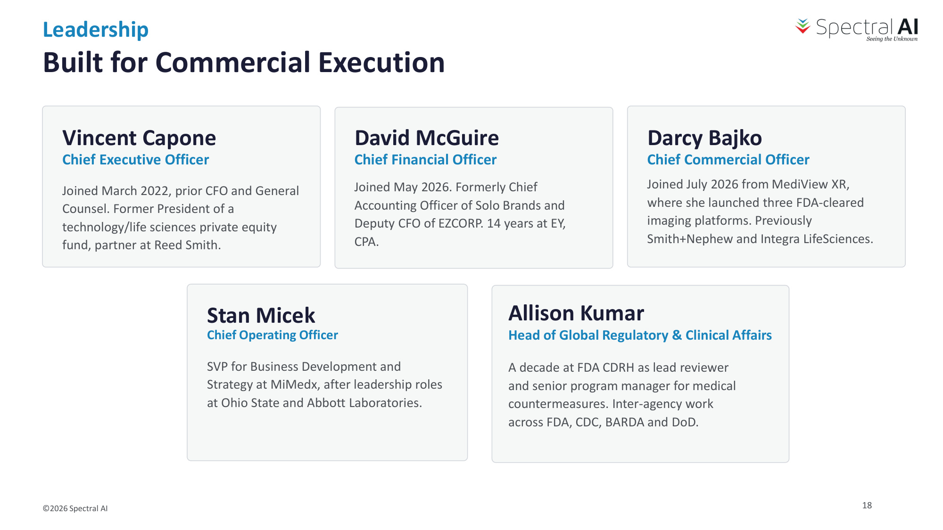
Leadership Built for Commercial Execution ©2026 Spectral AI Vincent Capone Chief Executive Officer Joined March 2022, prior CFO and General Counsel. Former President of a technology/life sciences private equity fund, partner at Reed Smith. David McGuire Chief Financial Officer Joined May 2026. Formerly Chief Accounting Officer of Solo Brands and Deputy CFO of EZCORP. 14 years at EY, CPA. Stan Micek Chief Operating Officer SVP for Business Development and Strategy at MiMedx, after leadership roles at Ohio State and Abbott Laboratories. Darcy Bajko Chief Commercial Officer Joined July 2026 from MediView XR, where she launched three FDA-cleared imaging platforms. Previously Smith+Nephew and Integra LifeSciences. Allison Kumar Head of Global Regulatory & Clinical Affairs A decade at FDA CDRH as lead reviewer and senior program manager for medical countermeasures. Inter-agency work across FDA, CDC, BARDA and DoD. 18

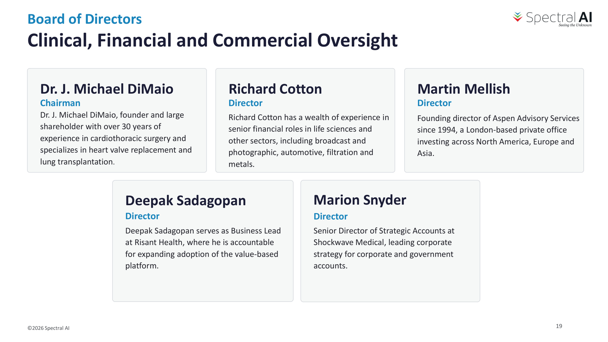
Board of Directors Clinical, Financial and Commercial Oversight ©2026 Spectral AI Dr. J. Michael DiMaio Chairman Dr. J. Michael DiMaio, founder and large shareholder with over 30 years of experience in cardiothoracic surgery and specializes in heart valve replacement and lung transplantation. Richard Cotton Director Richard Cotton has a wealth of experience in senior financial roles in life sciences and other sectors, including broadcast and photographic, automotive, filtration and metals. Deepak Sadagopan Director Deepak Sadagopan serves as Business Lead at Risant Health, where he is accountable for expanding adoption of the value-based platform. Martin Mellish Director Founding director of Aspen Advisory Services since 1994, a London-based private office investing across North America, Europe and Asia. Marion Snyder Director Senior Director of Strategic Accounts at Shockwave Medical, leading corporate strategy for corporate and government accounts. 19

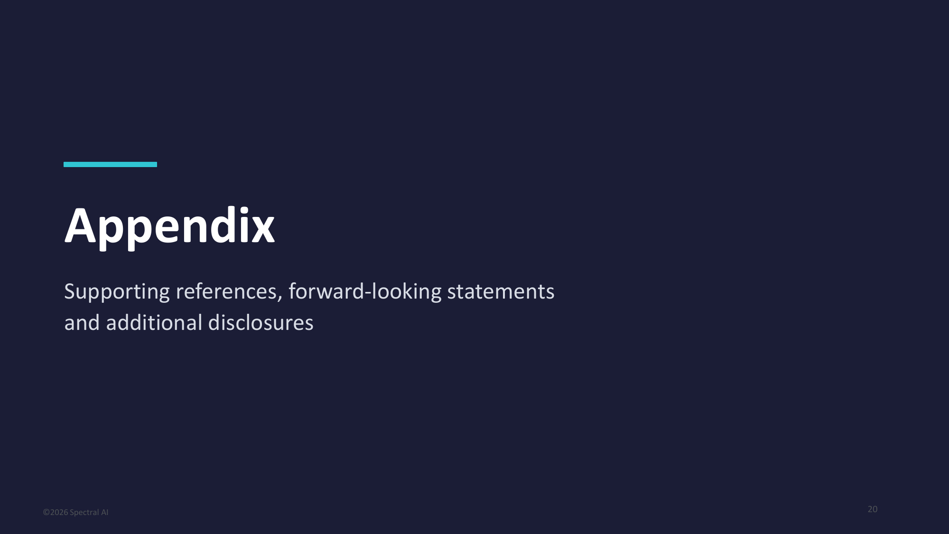
Appendix Supporting references, forward-looking statements and additional disclosures ©2026 Spectral AI 20

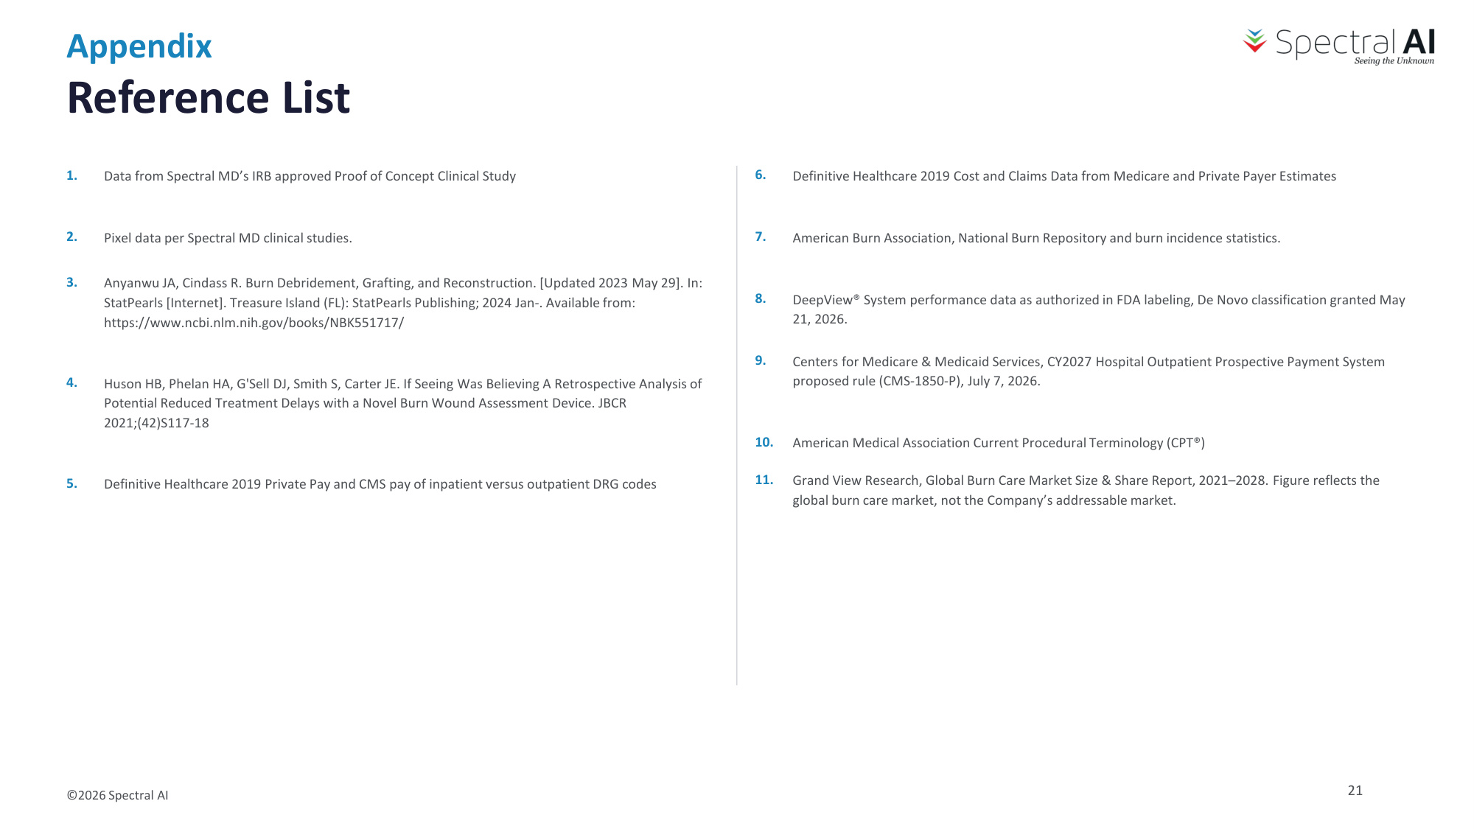
Appendix Reference List ©2026 Spectral AI 1. Data from Spectral MD's IRB approved Proof of Concept Clinical Study 2. Pixel data per Spectral MD clinical studies. 3. Anyanwu JA, Cindass R. Burn Debridement, Grafting, and Reconstruction. [Updated 2023 May 29]. In: StatPearls [Internet]. Treasure Island (FL): StatPearls Publishing; 2024 Jan-. Available from: https://www.ncbi.nlm.nih.gov/books/NBK551717/ 4. Huson HB, Phelan HA, G'Sell DJ, Smith S, Carter JE. If Seeing Was Believing A Retrospective Analysis of Potential Reduced Treatment Delays with a Novel Burn Wound Assessment Device. JBCR 2021;(42)S117-18 5. Definitive Healthcare 2019 Private Pay and CMS pay of inpatient versus outpatient DRG codes 6. Definitive Healthcare 2019 Cost and Claims Data from Medicare and Private Payer Estimates 7. American Burn Association, National Burn Repository and burn incidence statistics. 8. DeepView® System performance data as authorized in FDA labeling, De Novo classification granted May 21, 2026. 9. Centers for Medicare & Medicaid Services, CY2027 Hospital Outpatient Prospective Payment System proposed rule (CMS-1850-P), July 7, 2026. 10. American Medical Association Current Procedural Terminology (CPT®) 21 11. Grand View Research, Global Burn Care Market Size & Share Report, 2021–2028. Figure reflects the global burn care market, not the Company's addressable market.

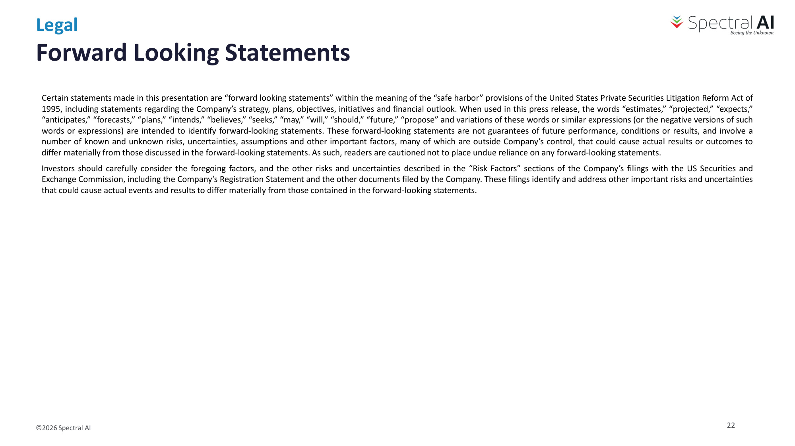
Forward Looking Statements Certain statements made in this presentation are "forward looking statements" within the meaning of the "safe harbor" provisions of the United States Private Securities Litigation Reform Act of 1995, including statements regarding the Company's strategy, plans, objectives, initiatives and financial outlook. When used in this press release, the words "estimates," "projected," "expects," "anticipates," "forecasts," "plans," "intends," "believes," "seeks," "may," "will," "should," "future," "propose" and variations of these words or similar expressions (or the negative versions of such words or expressions) are intended to identify forward-looking statements. These forward-looking statements are not guarantees of future performance, conditions or results, and involve a number of known and unknown risks, uncertainties, assumptions and other important factors, many of which are outside Company's control, that could cause actual results or outcomes to differ materially from those discussed in the forward-looking statements. As such, readers are cautioned not to place undue reliance on any forward-looking statements. Investors should carefully consider the foregoing factors, and the other risks and uncertainties described in the "Risk Factors" sections of the Company's filings with the US Securities and Exchange Commission, including the Company's Registration Statement and the other documents filed by the Company. These filings identify and address other important risks and uncertainties that could cause actual events and results to differ materially from those contained in the forward-looking statements. ©2026 Spectral AI Legal 22

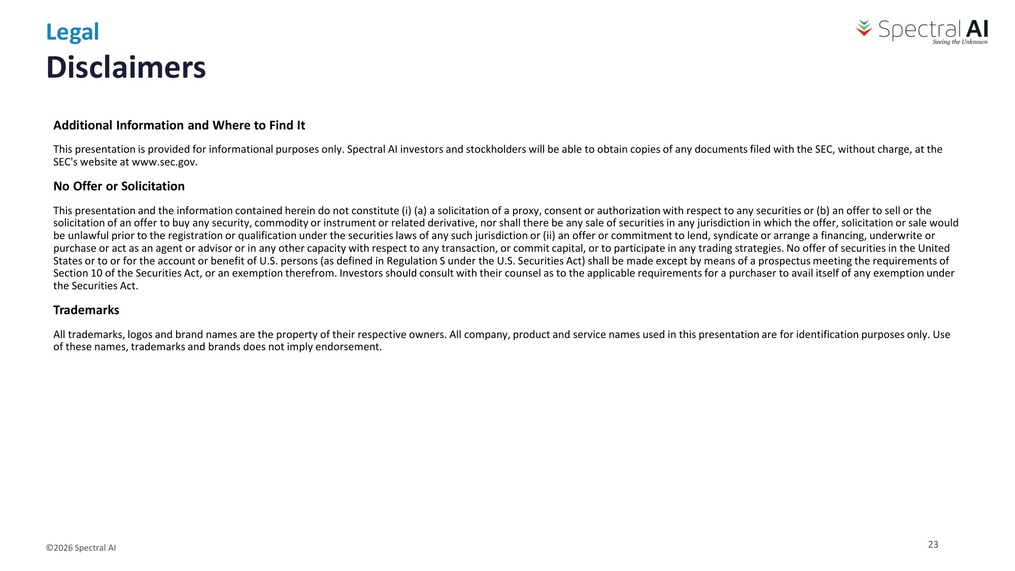
Additional Information and Where to Find It This presentation is provided for informational purposes only. Spectral AI investors and stockholders will be able to obtain copies of any documents filed with the SEC, without charge, at the SEC's website at www.sec.gov. No Offer or Solicitation This presentation and the information contained herein do not constitute (i) (a) a solicitation of a proxy, consent or authorization with respect to any securities or (b) an offer to sell or the solicitation of an offer to buy any security, commodity or instrument or related derivative, nor shall there be any sale of securities in any jurisdiction in which the offer, solicitation or sale would be unlawful prior to the registration or qualification under the securities laws of any such jurisdiction or (ii) an offer or commitment to lend, syndicate or arrange a financing, underwrite or purchase or act as an agent or advisor or in any other capacity with respect to any transaction, or commit capital, or to participate in any trading strategies. No offer of securities in the United States or to or for the account or benefit of U.S. persons (as defined in Regulation S under the U.S. Securities Act) shall be made except by means of a prospectus meeting the requirements of Section 10 of the Securities Act, or an exemption therefrom. Investors should consult with their counsel as to the applicable requirements for a purchaser to avail itself of any exemption under the Securities Act. Trademarks All trademarks, logos and brand names are the property of their respective owners. All company, product and service names used in this presentation are for identification purposes only. Use of these names, trademarks and brands does not imply endorsement. Disclaimers ©2026 Spectral AI Legal 23

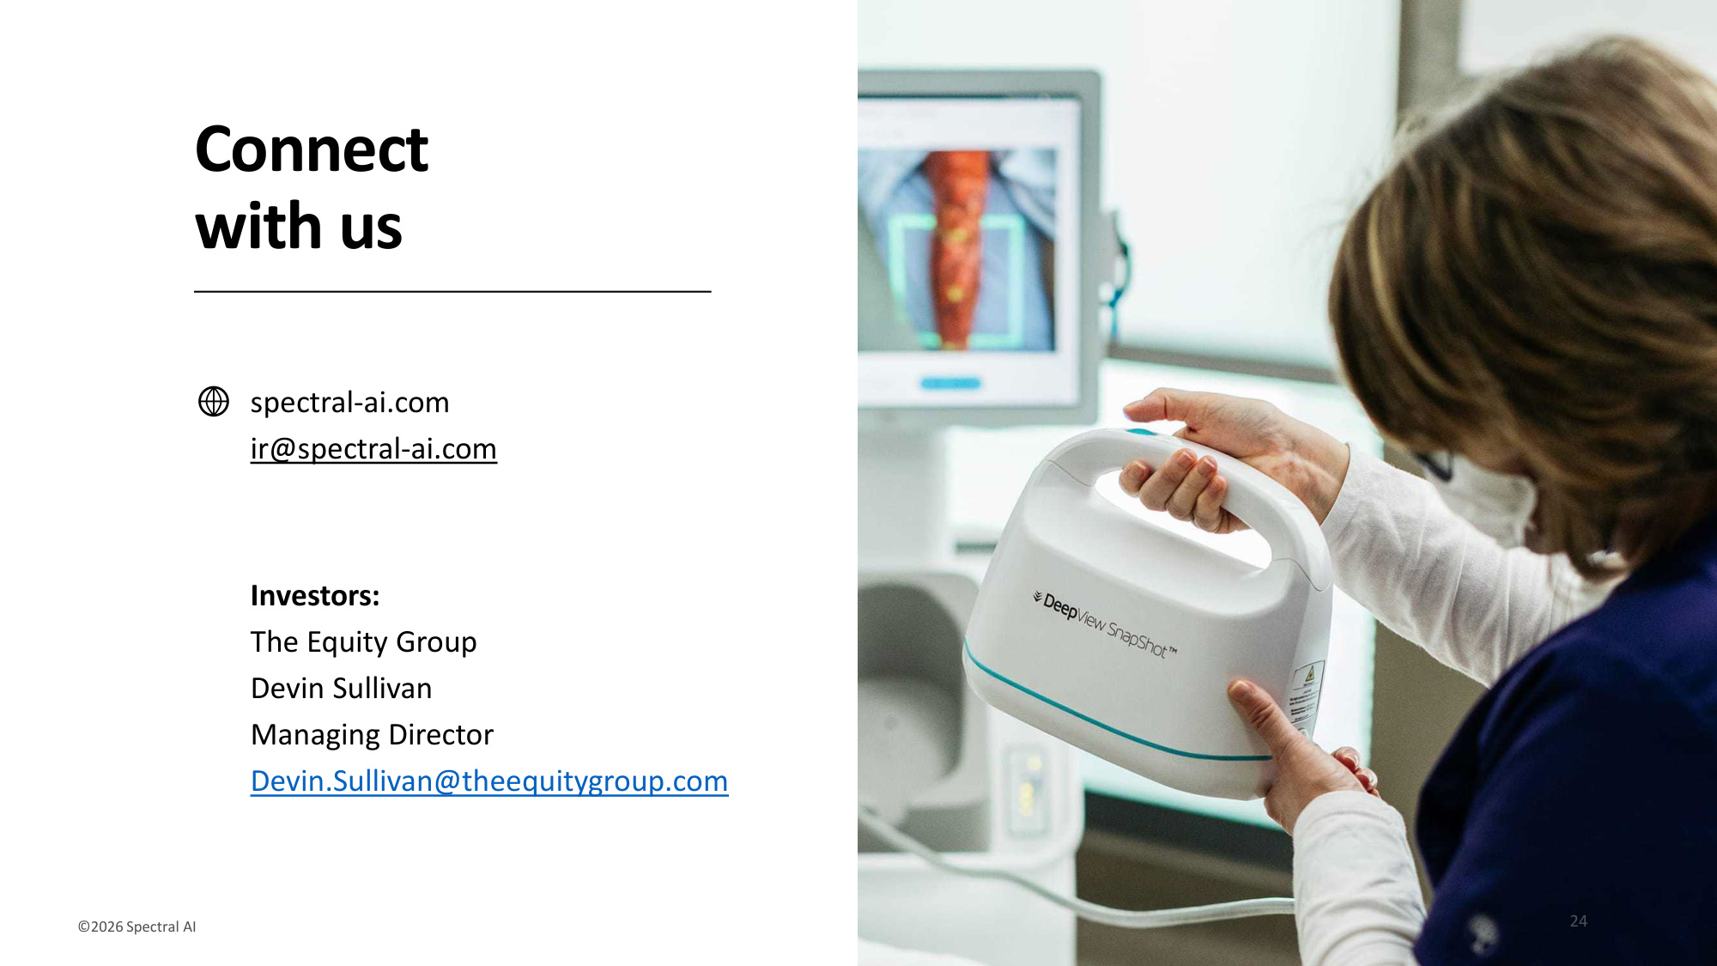
spectral-ai.com ir@spectral-ai.com Connect with us ©2026 Spectral AI Investors: The Equity Group Devin Sullivan Managing Director Devin.Sullivan@theequitygroup.com 24

